Client help

**Table of contents**

About Easy Order ? 4

Genreral instructions  4

Entity ? 4

Email Notifications ? 4

Customer  4

Login screen  5

Access  5

Login  5

Change Password  5

Inactivity Timeout  6

General functionality 6

Saving your Changes  6

Refreshing a Screen  7

Closing a Screen  7

Table Structure  7

Administration Menu  7

Users Screen  7

Roles Screen  8

Roles 9

Permissions  9

Permissions for screen access  9

Permissions to add, delete, update and view tables ? 10

Setup Menu ? 10

Coukd possibly be doing the other pages up here  10

Brands screen  10

**About Easy Order ?**

Easyorder is a online ordering system that allows you to order custom cabinets ...... It has two seperate faces the customer front end and the client back end. (keep explaining here)

*Created with the Personal Edition of HelpNDoc:* [*Easily create iPhone documentation*](https://www.helpndoc.com/feature-tour/iphone-website-generation)

**Genreral instructions**

Easyorder contains two web applications, a client application to process orders and a mobile application for customers to create and submit orders. The client application is built using Lightswitch Silverlight while the mobile application is built using Lightswich HTML5 which is compatible with most devices including tablets, ipads and smart phones.

*Created with the Personal Edition of HelpNDoc:* [*Full-featured Documentation generator*](https://www.helpndoc.com)

**Entity ?**

Each customer is assigned to an entity. An entity can be referred to as a division of Panelform. You can create as many entities as is required. Each entity is assigned an email address; Easy Order will send notifications via email when an order is submitted. Each entity is assigned a minimum order lead time (in days) this is used in setting up a default due date when a new order is created by a customer.

*Created with the Personal Edition of HelpNDoc:* [*Create cross-platform Qt Help files*](https://www.helpndoc.com/feature-tour/create-help-files-for-the-qt-help-framework)

**Email Notifications ?**

Email notifications are sent when an order status is changed as follow:

Status changed from anything to:

* New Email sent to customer. (Note: no emails are sent when an order is created and assigned the status “New”. The email will only be sent if the status of an existing order is changed to “New”, this is the case when and order is unlocked and sent back to a customer to allow the customer to make changes to the order.)
* Submitted Email sent to Panelform
* Downloaded Email sent to customer?
* Completed Email sent to customer?
* Shipped Email sent to customer?
* Closed ???

*Created with the Personal Edition of HelpNDoc:* [*Free Qt Help documentation generator*](https://www.helpndoc.com)

**Customer**

Orders and organized by Customers. Each customer is given a username and password to login to the mobile application. Once logged in, each customer will only have access to their own orders. Customers can use the mobile app to create, update or delete an order. Selection on items, products, styles, types, edges, colours, brands and finishes are determined by table setup in the client application. Easyorder automatically calculates the cost for each item added to an order based on the tables in the client application. Orders can be submitted to Panelform using the mobile application. Easyorder will send a notification via email when an order is submitted. Submitted orders are locked, customers can't delete or change locked orders. Only users with administrative rights can unlocked an order using the client application.

*Created with the Personal Edition of HelpNDoc:* [*Free EPub producer*](https://www.helpndoc.com/create-epub-ebooks)

**Login screen**

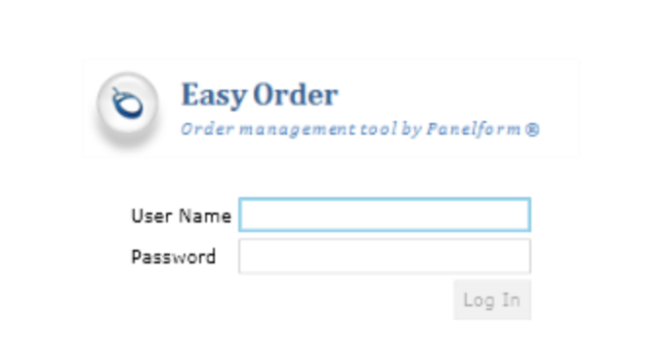

*Created with the Personal Edition of HelpNDoc:* [*Free HTML Help documentation generator*](https://www.helpndoc.com)

**Access**

Acess

URL: <https://panelform-easyorder-client.azurewebsites.net/client/>

*Created with the Personal Edition of HelpNDoc:* [*Free EPub and documentation generator*](https://www.helpndoc.com)

Login

To login you need a username and password login. Usernames and passwords are case sensitive.

*Created with the Personal Edition of HelpNDoc:* [*Create help files for the Qt Help Framework*](https://www.helpndoc.com/feature-tour/create-help-files-for-the-qt-help-framework)

Change Password

Once a user is logged in, their name will be displayed in the top right corner of the web application next to the words "change password". To change your password click on the Change Password link, you will be prompted for your current password and new password as per the form below.

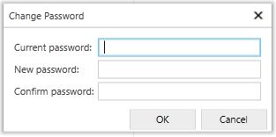

*Created with the Personal Edition of HelpNDoc:* [*Easily create CHM Help documents*](https://www.helpndoc.com/feature-tour)

Inactivity Timeout

When a website is inactive for more than 5 mins, you will be requested to log back in again using the form below

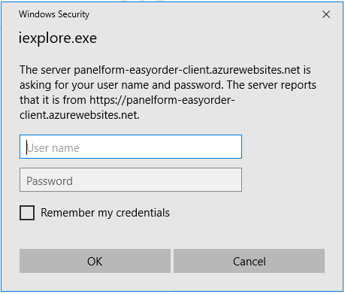

*Created with the Personal Edition of HelpNDoc:* [*Free help authoring environment*](https://www.helpndoc.com/help-authoring-tool)

**General functionality**

General functionality will describe how to save your changes, refresh your screen and how to close a screen.

*Created with the Personal Edition of HelpNDoc:* [*Free EPub producer*](https://www.helpndoc.com/create-epub-ebooks)

**Saving your Changes**



Easyorder is a data centric web application. In this type of application, screens are directly connected to data tables based on a client/server configuration. This typically means that changes to your screen are not saved in the data base until you manually click on the save button.

When you make a change to the screen, a * (star) will appear next to the record as per picture below. Once you save your changes, the * (star) will disappear. It is good custom to save your changes frequently, if an error occurs in the process of saving the screen data, you may loose all your changes.

*Created with the Personal Edition of HelpNDoc:* [*Benefits of a Help Authoring Tool*](https://www.helpauthoringsoftware.com)

**Refreshing a Screen**



If an error occurs as a result of saving your changes or otherwise. Click the Refresh button and select "Discard Changes" when prompted.

*Created with the Personal Edition of HelpNDoc:* [*Qt Help documentation made easy*](https://www.helpndoc.com/feature-tour/create-help-files-for-the-qt-help-framework)

**Closing a Screen**



To close a tab, click on the close button in the main menu at the bottom of the screen or hover over at the tab a the top to reveal a "X" and click on the "X" as per the picture below

There is no "Log Out" button, to logout, simply close the internet tab running the web application. Please note, your web browser will remember your login details, so next time you navigate to the Coachmaster web application's website, you will be automatically logged back in, unless you have had the site closed for more than 5 minutes. If you want to log back in as another user, close your internet explorer and restart. This will erase the login details from your memory and prompt you for a password.

*Created with the Personal Edition of HelpNDoc:* [*Generate EPub eBooks with ease*](https://www.helpndoc.com/create-epub-ebooks)

**Table Structure**

*Created with the Personal Edition of HelpNDoc:* [*Free iPhone documentation generator*](https://www.helpndoc.com/feature-tour/iphone-website-generation)

**Administration Menu**

The administration menu allows you to

*Created with the Personal Edition of HelpNDoc:* [*Easily create Help documents*](https://www.helpndoc.com/feature-tour)

**Users Screen**

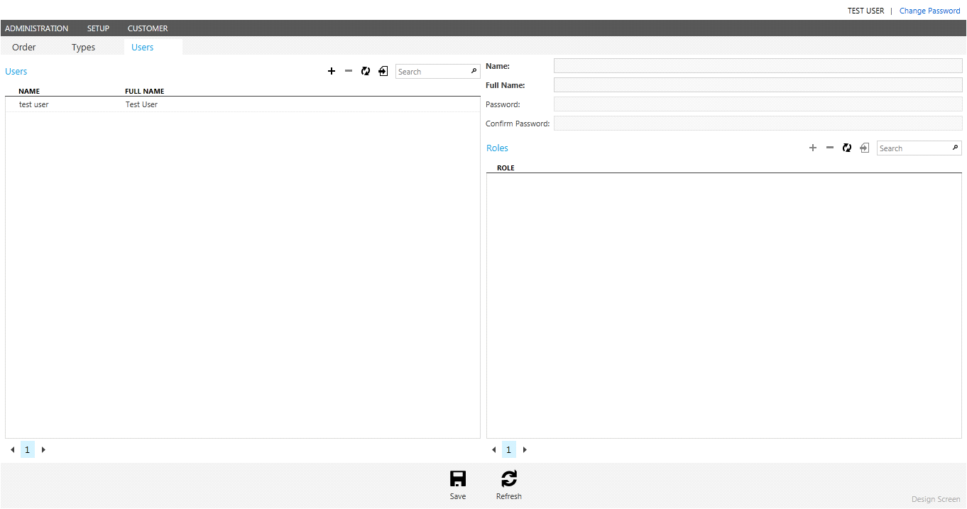

Users

* The users list shows all available logins for Easyorder.
* To add or delete a user, use the small buttons in the top right corner of the roles list and click save.

Roles

* The roles list shows all roles assigned assigned to the selected user
* To add or remove a role for the selected user, use the small buttons in the top right corner of the roles list and click save
* To add, edit or remove roles, use the roles screen in the administration menu.

Change Password

* An administrator with access to this screen can update another user's password by selecting the user record in the users list, and typing the new password in the password and confirm password textbox and click save.

*Created with the Personal Edition of HelpNDoc:* [*Free help authoring tool*](https://www.helpndoc.com/help-authoring-tool)

**Roles Screen**

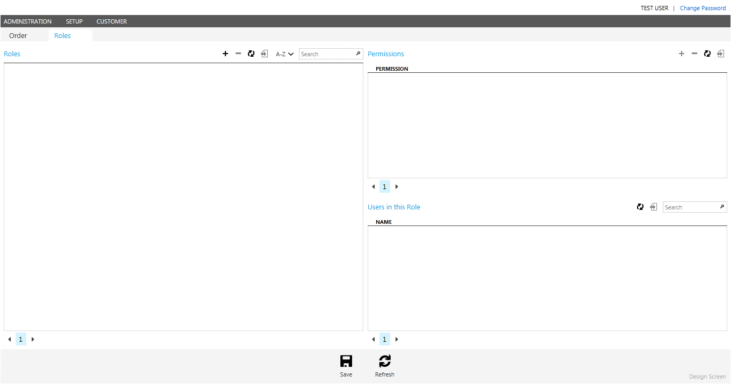

*Created with the Personal Edition of HelpNDoc:* [*Full-featured EBook editor*](https://www.helpndoc.com/create-epub-ebooks)

**Roles**

* The Roles list contains all the roles available in Easyorder.
* A role contains a set of permissions. Some permissions provide access to screens, other permissions provide rights to add, update, delete and view tables
* To add or delete a role, use the small buttons in the top right corner of the Users list and click Save.
* The users list shows all available logins for Coachmaster
* To add or delete a user, use the small buttons in corner of the users the top right Users list and click save.
* Use the Users screen to assign a role to a user.

*Created with the Personal Edition of HelpNDoc:* [*Free EBook and documentation generator*](https://www.helpndoc.com)

**Permissions**

* The Permissions list shows all the permissions assigned to the selected role.
* To assign or remove a permission from a role, use the small buttons in the top right corner of the permissions list snd click save

*Created with the Personal Edition of HelpNDoc:* [*Generate EPub eBooks with ease*](https://www.helpndoc.com/create-epub-ebooks)

**Permissions for screen access**

* The table below shows permissions which provide access to screens. These permissions need to be included in the list of permissions assigned to a role.

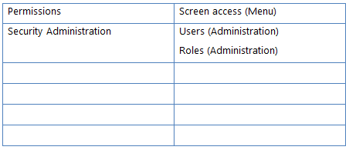

*Created with the Personal Edition of HelpNDoc:* [*Free Web Help generator*](https://www.helpndoc.com)

**Permissions to add, delete, update and view tables ?**

* Each screen contains a set of functions; each function is related to table access permissions.
* The default table access permissions for each role are set out below.
* New Roles can be created and customised.

*Created with the Personal Edition of HelpNDoc:* [*Produce electronic books easily*](https://www.helpndoc.com/create-epub-ebooks)

**Setup Menu ?**

*Created with the Personal Edition of HelpNDoc:* [*Full-featured Kindle eBooks generator*](https://www.helpndoc.com/feature-tour/create-ebooks-for-amazon-kindle)

**Coukd possibly be doing the other pages up here**

*Created with the Personal Edition of HelpNDoc:* [*Easily create EPub books*](https://www.helpndoc.com/feature-tour)

**Brands screen**

*Created with the Personal Edition of HelpNDoc:* [*Produce online help for Qt applications*](https://www.helpndoc.com/feature-tour/create-help-files-for-the-qt-help-framework)